TASK 4 - Trend Analysis by Release Year
First Visual Output:
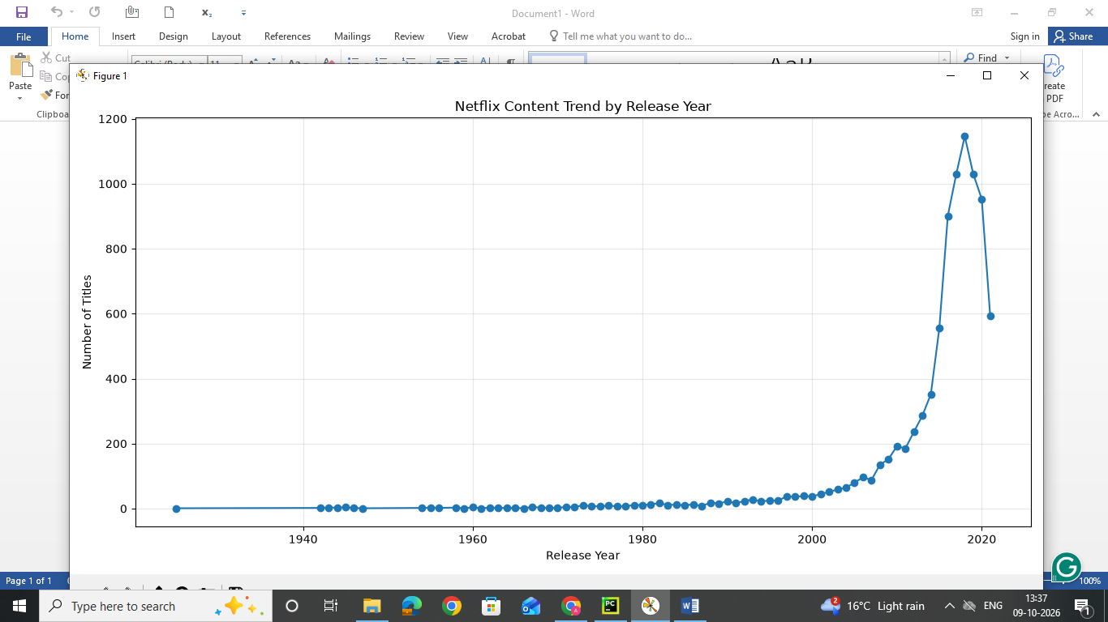

Second Visual Output:
